**Title of the article (not more than 15 words; Font: Times New Roman, size 14)**

**Author Name[](https://orcid.org/0000-0000-0000-0000)1, Author Name[](https://orcid.org/0000-0000-0000-0000)1, and Author Name[](https://orcid.org/0000-0000-0000-0000)2** 

1*Department/School, University/Institute, City (ZIP Code), State, Country.*

2*Department/School, University/Institute, City (ZIP Code), State, Country.*

**Supplementary Data,** if any,for this article is available online [link](https://theabcjournal.com)

**Abstract:** This document is a template for Microsoft Word for the final publication of the accepted manuscript in The Applied Biology & Chemistry Journal (TABCJ). This template should be used in accordance to the journal guidelines mentioned in the [Instructions for Authors](Final%20https:/theabcjournal.com/index.php/home/instructions-for-authorsTemplate%20for%20Accepted%20Manuscript.docx) page of the journal. The abstract should be non-segmented and between 200-250 words in Times New Roman (size 10) font. The abstract should be written as an objective illustration of the article, and it must not comprise results, which are not presented and validated in the main text and should not overstate the core conclusions. The final reviewed and validated abstract should be included here, no new edits are permitted at this stage.

K**eywords:** first keyword; second keyword; third keyword; fourth keyword; fifth keyword

List atleast four to seven relevant keywords explicit to the article seperated by (;) and are reasonably common in the subject area. Please ensure that your article is optimized for search engines. Keywords should appear in the title, abstract and throughout your article to increase your article’s online visibility. (Delete the lines in purple after adding your text)

NOTE: The contents indicated in red to be filled in by the editorial office. Please do not edit or modify these sections of the template. Please don’t change the font style and size. Please don’t change the formatting style of the template.

**Received** Month DD, YYYY

**Revised** Month DD, YYYY

**Accepted** Month DD, YYYY

**Published** Month DD, YYYY



Copyright: © YYYY First author, Second author, third author, et al. This is an open access article distributed under the terms of the **Creative Commons Attribution License**, which permits unrestricted use, distribution, and reproduction in any medium, provided the original author and source are credited.

1. **Main text heading (Times New Roman, Bold, 10)**

The main text headings of the manuscript should be divided into the following numbered sections for Original Research and Short Communication type of articles:



Dr. Corresponding Author

Department/ School name,

Name of the university/institute

City, State – ZIP Code, Country

E-mail: email@institute.com

**1. Introduction**

**2. Experimental or Materials and methods**

**3. Results and discussion**

**4. Conclusion**

The main text of the manuscript should be written in Times New Roman (size 10). These sections can be subdivided into subsections and subsubsections

* 1. **Subsection** (Times New Roman, Bold, 10)
     1. ***Subsubsection*** (Times New Roman, Bold, Italics, 10)

The section headings of the review articles, mini-reviews, perspectives, and editorial are of the authors’ choice and they can select the headings as per the demand of the article. In the accepted articles, after peer-review, the sections, subsections and subsubsections, will be typesetted as validated and approved during the review and editorial process.

**2. Illustrations (Figures and tables)**

**2.1 Figures and schemes**

Figures and schemes should be numbered sequentially. Citation of figures should use the following format: Fig. 1, Fig. 2, etc. Parts in a figure can be identified by A, B, C, D, … and cited as Fig. 2A, Fig. 2B, Fig. 2C.

Figures should be of high quality and the following are the resolutions for different figures: for line art, it must be at least 1200 dpi, for color images and single tone or black and white images 600 dpi or higher. Internet downloaded graphics are not acceptable because those graphics have 72 dpi resolution which is too low for satisfactory reproduction. It is recommended to use the highest quality figures, figures should not be inappropriately stretched or compressed from the sides but from the corners to fit in the content space within the pages. The figures should be placed near to the first mention/ citation of the figure in the main text. Figure legend (or caption) should be inclusive and each subfigure/panel/plate should be mentioned in the legend itself. Consider the above figure and legend as an example.

**Figure 1.** Various sampling sites in the Sambhar Lake, (a) Saltpan; (b) Soil from Lake Shore and (c) Reservoir water.

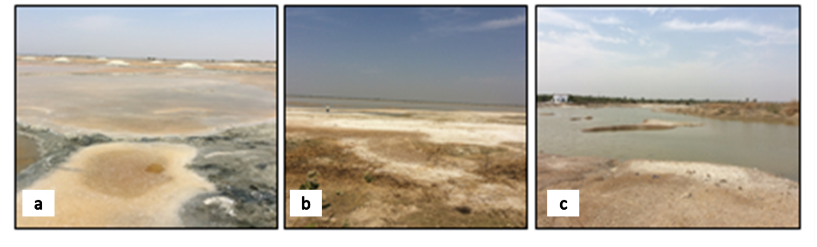

In case of micrographs or microscopic images, mark the scale and resolution on each figure and also indicate the same in the legend. In case of graphs or statistical representation, mark the necessary statistical symbols within the illustration and indicate the same in the legend.

**2.2 Tables**

Tables should be created/ formatted using MS word table format. Tables must be editable, and not as images. Tables should be numbered sequentially and should use the following format: Table 1, Table 2, … Do not abbreviate the word ‘Table’ to ‘Tab.’ or ‘tab.’. The table should be placed within the text near to first mention/ citation of the table in the main text. In case of lengthy table, consider placing it in supplementary materials.

1. **Mathematical expressions and equations**

Use Insert equation option of the MS Word for including mathematical expression and equation in the main text of the manuscript. For that, click on Insert, then on the right corner, select the type of equation to be used from the drop-down menu or click on ‘insert new equation’ for customizing and writing your mathematical expression.

**4. Abbreviations**

Do not use abbreviations in the title, abstract and keywords. Abbreviations should only be indicated for those expanded notations which are used at least 3 or more frequently in the main text.

**Declarations**

**Author Contribution:** Authorship should be assigned only to those who have a substantial contribution to the reported work or study in either of the following categories: conceived of the idea or designed the study, conducted the research, analyzed the data, contributed new methods or models or wrote the manuscript.

**Acknowledgement:** Any support or assistance provided, which is not covered in the author contributions or funding section can be duly acknowledged in this section. Authors may add administrative and technical support or donations in kind (e.g., materials provided for experiments) in this section.

**Funding:** Please add the funding details for the reported work. Please verify the accuracy of the furnished details carefully. Please write ‘Not Applicable’ if no funding support or assistance used in the reported study.

**Conflict of Interest:** Declare conflict of interests, if any.

**Ethical approval:** This is an optional section of the declaration. Mention only if there is any approval from the institutional ethical committee was required for the conducting the reported study.

**References**

The Applied Biology & Chemitry Journal uses TABCJ-Vancouver Reference Style that follows a system of numbers in square brackets within the text when you are citing work and a numbered reference list at the end of your document. If you cite the same source more than once, use the same citation number for all citations. In text, numbers are matched to an entry in the reference list. See the examples.

Citations within the text:

For single reference [1]; for more than one reference [2, 5] or [1, 2, 7,9]; or [1-4] for more than one consecutive references.

Please list publications in the order they are cited in the text and not alphabetically, giving a numberical reference followed by the full reference for the publicaton you are citing. Please include DOI and PubMed ID, for all the cited references. Depositing DOIs for each of your references will ensure precise citations.

If the table contains the reference citations, then the references should be cited by the text after which the table should come in the content, i.e., where the table is cited for the first time within the text and refernce citation should continue after the table ends and the text resumes.

[1] Hisakata R, Nishida S, Johnston A (2016). An adaptable metric shapes perceptual space. Curr Biol; 26:1911–5. https://doi.org/10.1016/j.cub.2016.05.047

[2] Musk E (2006). The secret Tesla Motors master plan (just between you and me). Tesla Blog. https://www.tesla.com/blog/secret-tesla-motors-master-plan-just-between-you-and-me (accessed September 29, 2016).

[3] Hogue CWV (2001). Structure databases. In: Baxevanis AD, Ouellette BFF, editors. Bioinformatics. 2nd ed., New York, NY: Wiley-Interscience; p. 83–109.

[4] Sambrook J, Russell DW (2001). Molecular cloning: a laboratory manual. 3rd ed. Cold Spring Harbor, NY: CSHL Press.

In case of multiple authors, after first five authors include ‘et al.’ in the reference as follows:

[5] Zhang X, Xia L, Liu J, Wang Z, Yang Y, et al. (2023). Comparative genomic analysis of a Methylorubrum rhodesianum MB200 isolated from biogas digesters provided new insights into the carbon metabolism of methylotrophic bacteria. *Int J Mol Sci*; 24(8):7521.